Instruction for System A

(This instruction is assumed to run on Windows system to run bat file.)  
**1. To start the system:**1-1.       Open command prompt window  
1-2.       Open SystemA folder  
1-3.       Type **Start.bat** on command prompt window and hit Enter.  
1-4.       When a message that “Starting ECS system” is appeared, then hit Enter key.  
1-5.       Then, original system consoles will be appeared on a screen.  
1-6.       To operate security system, hit Enter key again on the command prompt window.  
1-7.       Then, console windows related to security system will be appeared on the screen.    
  
**2. To operate the system:**  
2-1. Among consoles of security system, you need to find “MUSEUM ENVIRONMENT CONTROL SYSTEM SECURITY CONSOLE”.  It looks like this.

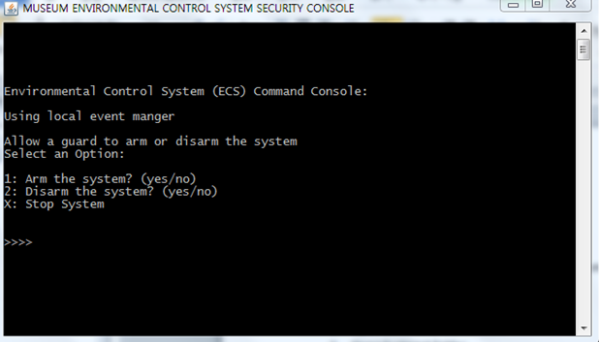

2-2. Put number (1 or 2) to test the system or “X” to stop and exit the system.

2-3. If you type “1” to arm the system, then three options will be appeared on the console.

2-3-1. If you type “a” and hit enter key, then simulated door broken event will be occurred. (You can check whether the event is reported or not on the *monitor console*)

2-3-2. If you type “b” and hit enter key, then simulated window broken event will be occurred.

2-3-3. If you type “c” and hit enter key, then simulated motion detected event will be occurred.